Partnerships in Education
Spring 2020
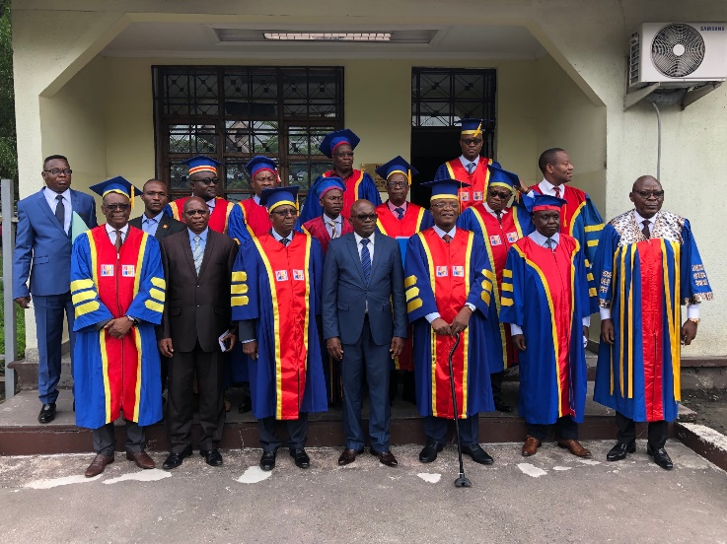

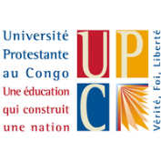
Founded in 1959, Université Protestante au Congo (UPC) celebrated its 60th Anniversary December 6, 2019.
In his opening address University Chancellor Daniel Ngoy (himself an alumnus) applauded UPC's accomplishments. "We have seen so much progress and look forward to the future." Among those accomplishments, the Chancellor cited the impressive figure of 20,000 bachelor's degrees that have been bestowed on UPC graduates since 1959!
Université Protestante au Congo was created in 1959 on the initiative of the Church of Christ in Congo (a coalition of most Protestant churches in Congo, notably including Baptists, Disciples of Christ, Methodists, Presbyterians, and Mennonites) and began theology classes in 1960 in Lubumbashi. During years of uncertain security and political environments UPC
moved to Kisangani and then to Kinshasa, where it operated in several locations before settling permanently into its present location.
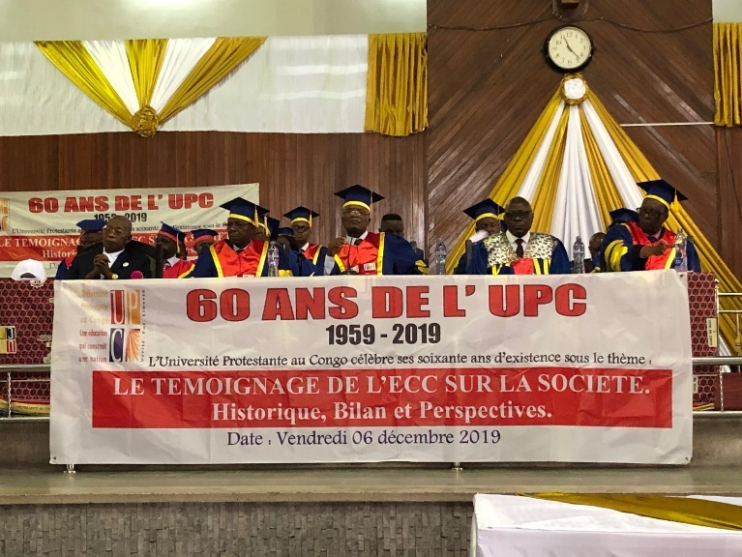

The University's vision to spread throughout Congolese society the Christian values that are taught in its School of Theology led to the addition of four more Schools. In 1989 the University opened the School of Social Studies, followed by the schools of Business and of Law in 1994. The School of Medicine opened in 2006 and is graduating about one hundred doctors per year. The newest addition is the School of Computer Sciences, in 2017.
Education is all a matter of building bridges
- Ralph Ellison

Education Congo is proud to have walked alongside the University 21 of these years, providing scholarships and project funds to enhance the educational capacity of the institution as well as to enable many students to complete their studies. The founders of Education Congo, Jim Decker, Lamar Williamson, Ben Hobgood and Melville Loewen, were also Professors and some were Rectors at the University in its early years . The story of Education Congo is therefore deeply enmeshed with that of the UPC. This year we all celebrate together the success of this incredible venture of faith and hope and hard work!
Education Congo has a unique offering for donors, a ‘Named Fund’, that enables long-term scholarship support for university students in the Democratic Republic of the Congo.
A Named Fund may be established in the name of the donor or in honor or in memory of one or more individuals. The initial gift may be in any amount, but the goal is to reach at least $25,000. One fiscal year after that occurs, scholarships will begin to go to the designated institution. Education Congo's management policy seeks to provide approximately equal scholarship amounts in the name of the honoree each year far into the future. This approach essentially maintains the fund’s principal and pays out of growth and interest.

Named Funds have grown substantially from the initial gift in 1998 to 39 Named Funds with a current value of $1,859,597 in 2019. Based on EC’s withdrawal management this enabled $39,860 in scholarship funds this past year. Annual fund growth increases capacity to respond to student needs.

Here’s how the Named Funds started:

Ben Hobgood, along with his wife Betsy, served several terms as missionaries in the Equateur province of Congo. He participated in the early years of UPC as professor and rector. After he returned to the United States, he continued to support the university and in 1998 recruited former colleagues to join him in setting up the North American Liaison Bureau (now DBA as
Education Congo, 2216 Elgin Road, Winston-Salem, NC 27103 - execdir@educationcongo.org
www.eductioncongo.org Education Congo
Education Congo) to raise scholarships for UPC students.

Since its incorporation and registration with the IRS as a 501(c)(3) charitable organization, EC has grown in financial strength and in the scope of its assistance to students at UPC and, more recently, the Evangelical University of Africa.

Ben soon recognized the importance of raising funds that would continue to provide scholarships in the long term. He set up the program for Named Funds, which donors could establish to express their continuing love for the people of Congo or to honor or commemorate family, friends, or others who had devoted their lives to missionary service. Ben himself established a Named Fund for his missionary parents, and a few years later his daughters in turn set up the Ben and Betsy Hobgood Named Fund with an initial gift of $500. As family members and others continued to contribute, the fund grew quickly and within two years reached a level which permitted it to distribute scholarships to UPC, which it has done every year since.

If you are interested in starting a Named Fund, please contact Doug Cardwell, Executive Director of Education Congo.

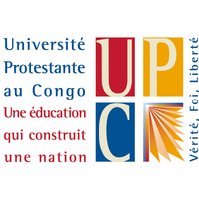
Education Congo’s website has a lot of information that may be of interest to you. It is user and mobile friendly and allows you to explore all about Education Congo, our partners UPC & UEA based in Kinshasa and Bukavu respectively, as well as our scholarship and medical projects and other programming. It also provides a place where you can donate to one of the Named Funds. The internet address is: www.educationcongo.org
